Sprint 2 Materials

Team S.M.E.A



Jose Ortiz

Nathan Tran

Kyle Palermo

Sandeep Mishra

Alex Beamer

Marvin Fung

# Retrospective Summary

In our retrospective meeting, we discussed what went wrong first. As a group, we were not content with the end product of this sprint. The reason we fell behind was due to merging conflicts which proved to be more difficult then what we anticipated. We also felt like the workload given was too much for one sprint. Things we did well was learning to connect our backend to our frontend to give our pages functionality. Another thing we did well was develop a better css file system which helped us keep the design consistency. Finally, although the workload was heavy and some of the tasks should have been assigned later, this allowed us to come into sprint 3 with the majority of the tasks started/completed which we as a group found positive. To improve our experience for the upcoming sprint, we decided to have more daily meetings to keep ourselves accountable and make sure progress is being made. We also discussed having a better system to resolve merging issues to avoid conflicts in the future. Lastly, we adjusted the backlog making sure we have all the important tasks listed. Our backlog goals to have some APIs and implement the rest of our manager's pages were not met due to the amount of workload and merging conflict as previously stated. However, we did make a considerable amount of progress with our tasks. With this progress, we are confident in finishing our tasks by the end of the sprint.

# GitHub Release Link

<https://github.com/csce-315-331-2024a/project-3-full-stack-agile-web-902-8/releases/tag/v2.0.0>

# Product Backlog

* Task: Create login interface (Root page)
  + A page that includes input fields for the user's username or email address and password for the website
  + Able to detect user (customer, staff, and manager)
  + Styling/designing layout
  + Include Revs Logo in the upper middle of page
  + Adding forgot password feature link (Maybe?)
* Priority: Important
* Dependencies: N/A
* User Story Points: 2
* Status: not started
* Task: Implement interface to be able to use touch interaction to navigate the interface
  + The interface recognizes standard touch gestures, including tap, swipe and pinch
  + Configure an API for touch interaction
  + Implement for all pages
* Priority: Important
* Dependencies: N/A
* User Story Points: 3
* Status: not started
* Task: Implement OAuth
  + Ensure that the login system is smooth for the HR manager and cashiers and the security and authorization is good.
* Priority: Important
* Dependencies: N/A
* User Story Points: 3
* Status: not started
* Task: Create graphing data page in Manager interface
  + Create a graph page in the Manager directory
  + Set up an efficient way for the user to select a time frame
  + Generate a graph for product usage, Sales in menu item, and what sells together with respective time frame
  + Have a way to organize graph content (from most sold/used to least sold/used or vice versa)
  + Have a Refresh button that will remove the current graph
  + Have a back button in the page to go back to main manager interface (dependent task)
  + Link page in main manager interface so its navigable
  + The graph is sorted by greatest to lowest
* Priority: Normal
* Dependencies: N/A
* User Story Points: 3
* Status: not started
* Task: Make changes to database schema
  + Account for the formatting, theme, and features for this new schema
* Priority: Important
* Dependencies: None
* User Story Points: 1
* Status: In progress
* Task: Implement OpenWeather
  + The application must successfully acquire an API key for OpenWeather
  + Users can get recommendations based of weather in customer interface
* Priority: Normal
* Dependencies: None
* User Story Points: 2
* Status: Not Started
* Task: Implement translation of website
  + Users can easily select their preferred language from a list of available languages in the website
  + Secure an API for google translate
  + Implement for all pages
* Priority: Normal
* Dependencies: None
* User Story Points: 3
* Status: Not Started
* Task: Implement functionality to Cashier Page
  + Implement functionality in category navigation bar (update bar with types we have in our menu)
  + Implement functionality in menu item buttons (update buttons with the amount of menu items in selected category type). If possible try to keep 5 buttons per row to keep structure
  + Implement remove functionality in order display (be able to remove menu item in order display) (Already implemented)
  + Implement place order functionality once place order button pressed (upload order to database, be able to display in Manager interface)
  + Implement logout, so once cashier logs out, goes to login page with empty text boxes
  + Change the quantity of the menu item to positive amount
* Priority: Important
* Dependencies: None
* User Story Points: 3
* Status: Completed
* Task: Create tax functionality for orders
  + Ensure that there is a button for adding/disabling tax for an order. Create this if it is not present.
  + Modify the logic for calculating the total for each order to include the tax when tax is enabled.
  + Connect the tax button to this logic.
  + Connect to every interface that checks an order (customer and cashier)
* Priority: Normal
* Dependencies: Implement functionality to Cashier Page
* User Story Points: 1
* Status: Completed
* Task: Create Global Styling
  + Create a standard set of CSS styles based on those used in the various pages already completed.
  + Replace the CSS used for pages and components with CSS that references the global styles.
  + Ensure that the CSS used for each page and component follows the desired file structure.
  + Ensure a consistent feel throughout site navigation.
* Priority: Important
* Dependencies: None
* User Story Points: 3
* Status: In Progress
* Task: Create css format of buttons
  + Design Back button
  + Design Refresh button
  + Design Logout button
* Priority: Normal
* Dependencies: Create Global Styling
* User Story Points: 1
* Status: Not Started
* Task: Create additional database queries
  + Modify database to fit our database schema
  + Create additional queries we may need
* Priority: Normal
* Dependencies: N/A
* User Story Points: 2
* Status: Complete (no additional queries were requested)

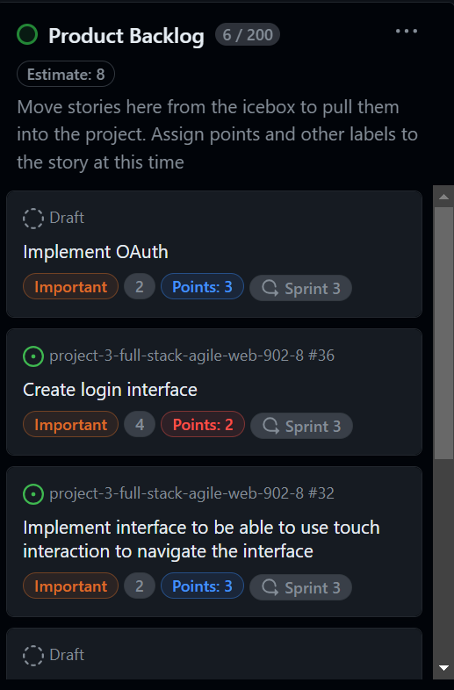

Sprint Backlog

* Task: Document files
  + document files that have not yet been documented
* Assigned to: Jose Ortiz
* Actual time spent: 1 hours
* Status: Completed
* Task: Create multiple links when Menu Board interface is clicked
  + Improve layout design
  + When interface is clicked, have different links for each menu board (for now we only have 2: entrees, Desserts & Beverages
  + ACTUALLY FILL OUT DESCRIPTION OF FOOD ITEM INCLUDE PICTURES
* Assigned to: Jose Ortiz
* Actual time spent: 1.5 hours
* Status: Completed
* Task: Create report page in Manager interface
  + Create a page in the Manager directory
  + Set up an efficient way for the user to select a time frame
  + Design a table that displays the Excess (least used inventory items) report
  + Design a table that displays the Restock report (should display the restock needed @ real time)
  + Make the tables generates appropriate data
  + Have a refresh button that will reset the tables
  + Have a back button in the page to go back to main manager interface (dependent task)
  + Link page in main manager interface so its navigable
* Assigned to: Jose Ortiz
* Actual time spent: 12.5 hours
* Status: Completed
* Task: Implement functionality to Cashier Page
  + Implement functionality in category navigation bar (update bar with types we have in our menu)
  + Implement functionality in menu item buttons (update buttons with the amount of menu items in selected category type). If possible try to keep 5 buttons per row to keep structure
  + Implement remove functionality in order display (be able to remove menu item in order display) (Already implemented)
  + Implement place order functionality once place order button pressed (upload order to database, be able to display in Manager interface)
  + Implement logout, so once cashier logs out, goes to login page with empty text boxes
  + Change the quantity of the menu item to positive amount
* Assigned to: Kyle Palermo
* Actual time spent: 24 hours
* Status: Completed
* Task: Create tax functionality for orders
  + Ensure that there is a button for adding/disabling tax for an order. Create this if it is not present.
  + Modify the logic for calculating the total for each order to include the tax when tax is enabled.
  + Connect the tax button to this logic.
  + Connect to every interface that checks an order (customer and cashier)
* Assigned to: Kyle Palermo
* Actual time spent: 2 hours
* Status: Completed
* Task: Create Global Styling
  + Create a standard set of CSS styles based on those used in the various pages already completed.
  + Replace the CSS used for pages and components with CSS that references the global styles.
  + Ensure that the CSS used for each page and component follows the desired file structure.
  + Ensure a consistent feel throughout site navigation.
* Assigned to: Kyle Palermo
* Actual time spent: 1 hour
* Status: Incomplete
* Task: Create css format of buttons
  + Design Back button
  + Design Refresh button
  + Design Logout button
* Assigned to: Kyle Palermo
* Actual time spent: 0 hours
* Status: Incomplete
* Task: Implement zoom functionalities and the button for it
  + The button for zoom in, zoom out, and reset are easily accessible and visible on all main pages
  + The zoom affects all contents on the webpage, including headers and paragraphs and excluding images
  + Implement for all pages
* Assigned to: Sandeep Mishra
* Actual time spent: 10 hours
* Status: Completed
* Task: Create graphing data page in Manager interface
  + Create a graph page in the Manager directory
  + Set up an efficient way for the user to select a time frame
  + Generate a graph for product usage, Sales in menu item, and what sells together with respective time frame
  + Have a way to organize graph content (from most sold/used to least sold/used or vice versa)
  + Have a Refresh button that will remove the current graph
  + Have a back button in the page to go back to main manager interface (dependent task)
  + Link page in main manager interface so its navigable
  + The graph is sorted by greatest to lowest
* Assigned to: Sandeep Mishra
* Actual time spent: 5 hours
* Status: Incomplete
* Task: Create Manage Inventory page in Manager interface
  + Create a new page for inventory content inside the manager directory
  + In the middle of the page, create a display template for inventory statistics (reference project 2). Display a blank screen when you first load into the page but update when the menu item is selected.

Should include:

* + - Name of the inventory name in the upper middle
    - Below the ingredient, have the name, current quantity, average price per pound, minimum quantity, and maximum quantity info
  + In the bottom have four buttons:
    - Add Item: when clicked it should clear content in each text box. Users can input information like normal. Have a confirm button that will upload new inventory item to database and a cancel button that scraps the drafted inventory item (confirm and cancel button should only appear if add menu item is clicked)
    - Save changes: which will update content of inventory item if anything changed
    - Delete Item: deletes the entire inventory item off the database
    - Request Item: Once pressed, pop up will appear where user will input quantity they wish to request from distributor
  + Create a right side navigation bar that will display the inventory items (arranged in alphabetical order). Once inventory is clicked, content will appear in display template
  + Have a back button in the page to go back to main manager interface (dependent task)
  + Link page in main manager interface so its navigable
* Assigned to: Nathan Tran
* Actual time spent: 10 hours
* Status: Complete
* Task: Create edit menu page in Manager interface
  + Create a new page for Menu content inside the manager directory
  + In the middle of the page, create a display template for menu item statistics (reference project 2). Display a blank screen when you first load into the page but update when the menu item is selected.
  + Should include:
    - Name of the menu item in the upper middle
    - Below the name, have the list of ingredients with the respective quantity with the ability to add or remove ingredients for the respective menu item
    - Below the ingredients, have the Name, Price, Net Price, Popularity, and seasonal info of the menu item
  + In the bottom have three buttons:
    - Add Menu Item: when clicked it should clear content in each text box. Users can input information like normal. Have a confirm button that will upload new menu item to database and a cancel button that scraps the drafted menu item (confirm and cancel button should only appear if add menu item is clicked)
    - Save changes: which will update content of menu item if anything changed
    - Delete menu Item: deletes the entire menu item off the menu
  + Create a right side navigation bar that will display the categories of the menu. When clicking a category, it will have a drop down list of all menu items in that category. Once menu item is clicked, content will appear in display template
  + Have a back button in the page to go back to main manager interface (dependent task)
  + Link page in main manager interface so its navigable
* Assigned to: Nathan Tran
* Actual time spent: 4 hours
* Status: Incomplete
* Task: Make changes to database schema
  + Account for the formatting, theme, and features for this new schema
* Assigned to: Alex Beamer
* Actual time spent: 6 hours
* Status: Incomplete
* Task: Implement OpenWeather
  + The application must successfully acquire an API key for OpenWeather
  + Users can get recommendations based of weather in customer interface
* Assigned to: Alex Beamer
* Actual time spent: 0 hours
* Status: Incomplete
* Task: Implement translation of website
  + Users can easily select their preferred language from a list of available languages in the website
  + Secure an API for google translate
  + Implement for all pages
* Assigned to: Alex Beamer
* Actual time spent: 0 hours
* Status: Incomplete
* Task: Create additional database queries
  + Modify database to fit our database schema
  + Create additional queries we may need
* Assigned to: Alex Beamer
* Actual time spent: 0 hours
* Status: Complete (no additional queries were requested)
* Task: Redesign Customer Menu Page
  + The design should match what is sketched out for the page
  + The menu items should be able to be clicked
  + It should be possible to change between the categories
  + The order on the side should be scroll able
  + The quantity of the item should be increment/decrement
* User Story Points: 2
* Assigned to: Marvin Fung
* Actual time spent: 11 hours
* Status: Complete
* Task: Implement functionality to Customer page
  + Implement functionality in category navigation bar (update bar with types we have in our menu)
  + Implement functionality in menu item buttons (update buttons with the amount of menu items in selected category type). If possible try to keep 5 buttons per row to keep structure
  + Implement logout in navigation bar
  + Display image of menu item and description of the item (list all ingredients in the description)
  + Allow user to choose the quantity with text box and have buttons (remove, increment, and decrement)
  + If user clicks the display of the menu item, add to their order
* User Story Points: 3
* Assigned to: Marvin Fung
* Actual time spent: 8 hours
* Status: Complete
* Task: Create order page in Customer directory
  + Create a new page in the customer directory
  + Link the order user input in the home page to this page
  + Display all the content of the order
  + Allow add/remove quantity button
  + Also allow user to input desired quantity they want to add or remove (in cases where they want to order 100 items or remove )
  + Implement checkout button (link to checkout page dependent task)
* User Story Points: 2
* Assigned to: Marvin Fung
* Actual time spent: 3 hours
* Status: In progress
* Task: Create checkout page in Customer directory
  + Create a checkout page in Customer directory
  + Only counter option (its Revs, unless it can be a little unrealistic we can add drive through or something)
  + Choose payment option
  + Displays the subtotal with sales tax
  + Charges subtotal + sales tax
* User Story Points: 2
* Assigned to: Marvin Fung
* Actual time spent: 3 hours
* Status: In progress
* Task: Implement a text to audio feature
  + Users can select specific portions of text they wish to have read aloud for or have another option to play audio for the entire website
  + Configure an API for text to audio
* User Story Points: 3
* Assigned to: Marvin Fung
* Actual time spent: 0 hours
* Status: Not completed

Summary Table:

| Team member | Sprint 2 user story points completion |
| --- | --- |
| Jose Ortiz (Scrum master) | 5 points |
| Alex Beamer | 0 points |
| Kyle Palermo | 4 points |
| Marvin Fung | 5 points |
| Nathan Tran | 5 points |
| Sandeep Mishra | 5 points |

# 

# Burn-down Charts

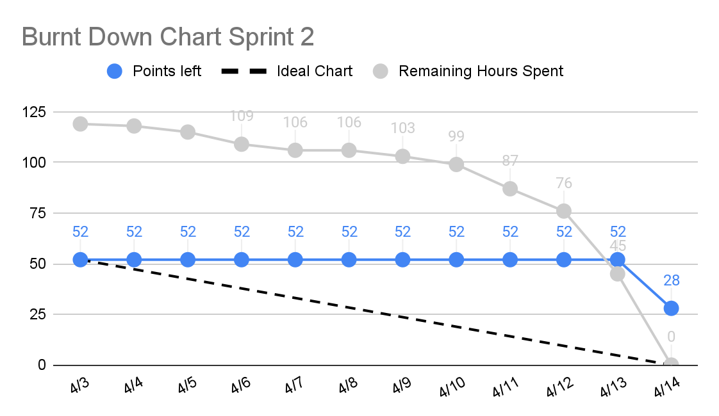

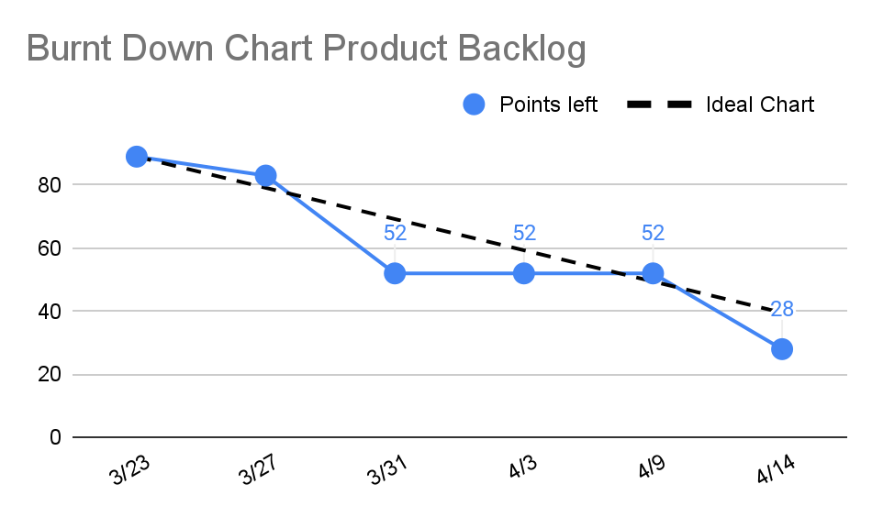

# 

# Next Sprint’s SCRUM Meeting Schedule

This is the list of when we are planning on meeting for the next sprint (hours might changed):

* Planning meeting: April 17th, 2024 at 6pm
* Planning meeting: April 19th, 2024 at 10am
* Planning meeting: April 23th, 2024 at 9:15am
* Planning meeting: April 28th, 2024 at 10am
* Retrospective meeting: April 29th, 2024 at 6pm

Appendix 1: SCRUM Meeting Agendas and Minutes

SCRUM Meeting Agendas and Minutes

SCRUM Planning Meeting for Project 3 Sprint 2

Prepared by: Jose Ortiz

Meeting Date: 4/2/2024

Start Time: 6pm

End Time: 7:25pm

## Meeting Attendees

1. Marvin Fung
2. Alex Beamer
3. Kyle Palermo
4. Sandeep Mishra
5. Nathan Tran

## Meeting Agenda Items

* Go over backlog and review tickets
* Discuss tasks distribution
* Discuss if any new tasks should be implemented
* Clear up any concerns

## Status Update Since Last Meeting

Accomplishments:

* Completed all our tasks assigned in sprint 1
* Went over as a group what we felt strong and what we need improvement on

Task Assignments:

| **Task Description** | **Assigned to** | **Completed?(yes/no)** |
| --- | --- | --- |
| Modifying database schema for upcoming sprint | Alex Beamer | Yes |

## Before The Next Meeting

Plans:

* Have a rough draft for each page in the making
* Have some functionality in all our interfaces
* Start API implementation for parts of our code where applicable

Task Assignments:

| **Task Description** | **Assigned to** |
| --- | --- |
| Create edit menu page in Manager interface | Nathan Tran |
| Implement a text to audio feature | Marving Fung |
| Implement OpenWeather | Alex Beamer |
| Create tax functionality for orders | Kyle Palermo |
| Implement zoom functionalities and the button for it | Sandeep Mishra |
| Implement translation of website | Alex Beamer |
| Create css format of buttons | Kyle Palermo |
| Create manage inventory page in manager interface | Nathan Tran |
| Create graphing data page in manager interface | Sandeep Mishra |
| Create report page in manager interface | Jose Ortiz |
| Implement functionality to Cashier page | Kyle Palermo |
| Implement functionality to Customer page | Marving Fung |
| Create order page in Customer directory | Marving Fung |
| Create checkout page in customer directory | Marvin Fung |
| Create multiple links when menu board interface is clicked | Jose Ortiz |
| Make changes to database schema | Alex Beamer |
| Modify database and create query functions we may need in future | Alex Beamer |
| Create Global Styling | Kyle Palermo |

## Minutes from Previous Meeting

From our previous meeting, we went over what we did well and what we needed to improve. This helped us establish a new mindset going into the next sprint with new ideas of what we can do to improve our efficiency. We also discussed how to use linter to help us make sure we are applying everything we need correctly. Lastly we discussed any roadblocks and brainstormed solutions for them. After conducting the fist of five vote, we had an average of 3 points because we are concerned time wise but as long as we keep a timely pace, we should be good.

SCRUM Daily Meeting 1 for Project 3 Sprint 2

Prepared by: Jose Ortiz

Meeting Date: 4/7/2024

Start Time: 6pm

End Time: 6:20pm

## Meeting Attendees

1. Marvin Fung
2. Alex Beamer
3. Kyle Palermo
4. Sandeep Mishra
5. Nathan Tran

## Meeting Agenda Items

* Checking everyone's progress in tasks
* Discuss how to implement user survey into our project
* Go over how we are feeling in terms of end goal
* Get ready for our presentation on thursdayStatus Update Since Last Meeting

## Status Update Since Last Meeting

Accomplishments:

* Established linter and prettier to help us format our code and make sure it's appropriate
* Created a better google sheet to track progress of members
* Fixed minor code issues that were not fixed before

Tasks Completed:

| **Task Description** | **Assigned to** | **Completed? (yes/no)** |
| --- | --- | --- |
| Create edit menu page in Manager interface | Nathan Tran | no |
| Implement a text to audio feature | Marving Fung | no |
| Implement OpenWeather | Alex Beamer | no |
| Create tax functionality for orders | Kyle Palermo | no |
| Implement zoom functionalities and the button for it | Sandeep Mishra | no |
| Implement translation of website | Alex Beamer | no |
| Create css format of buttons | Kyle Palermo | no |
| Create manage inventory page in manager interface | Nathan Tran | no |
| Create graphing data page in manager interface | Sandeep Mishra | no |
| Create report page in manager interface | Jose Ortiz | no |
| Implement functionality to Cashier page | Kyle Palermo | no |
| Implement functionality to Customer page | Marving Fung | no |
| Create order page in Customer directory | Marving Fung | no |
| Create checkout page in customer directory | Marvin Fung | no |
| Create multiple links when menu board interface is clicked | Jose Ortiz | no |
| Make changes to database schema | Alex Beamer | no |
| Create Global Styling | Kyle Palermo | no |

## Before The Next Meeting

Plans:

* We get at least 40% of our tasks completed
* Have an actual login page that would be needed for our project
* Have functionality with our main pages

Task Assignments:

| **Task Description** | **Assigned to** |
| --- | --- |
| No new task | N/A |

## Minutes from Previous Meeting

From our previous meeting, we planned our tasks and game plan for the upcoming sprint. We made sure to be more specific about our tasks to make sure everything makes sense. We assigned points based on scrum poker to have a fair bias when assigning tasks. After assigning points, we assigned tasks and went over any confusions there were for each task. After conducting the fist of five vote, we had an average of 3 points because although we feel better planned, we are still concerned with the workload since we have more tasks.

SCRUM Daily Meeting 2 for Project 3 Sprint 2

Prepared by: Jose Ortiz

Meeting Date: 4/10/2024

Start Time: 10:00am

End Time: 10:20am

## Meeting Attendees

1. Marvin Fung
2. Alex Beamer
3. Kyle Palermo
4. Sandeep Mishra
5. Nathan Tran

## Meeting Agenda Items

* Checking everyone's progress in tasks
* Discuss the APIs we think are worth adding to help our user stories
* Start discussion of which tasks to prioritize
* Discuss as a team any design flaws we need to overlook
* Discuss concerns regarding time tasks are taking

## Status Update Since Last Meeting

Accomplishments:

* Everyone started on their tasks
* Everyone learned to connect query functions to frontend

Tasks Completed:

| **Task Description** | **Assigned to** | **Completed? (yes/no)** |
| --- | --- | --- |
| Create edit menu page in Manager interface | Nathan Tran | no |
| Implement a text to audio feature | Marving Fung | no |
| Implement OpenWeather | Alex Beamer | no |
| Create tax functionality for orders | Kyle Palermo | no |
| Implement zoom functionalities and the button for it | Sandeep Mishra | no |
| Implement translation of website | Alex Beamer | no |
| Create css format of buttons | Kyle Palermo | no |
| Create manage inventory page in manager interface | Nathan Tran | no |
| Create graphing data page in manager interface | Sandeep Mishra | no |
| Create report page in manager interface | Jose Ortiz | no |
| Implement functionality to Cashier page | Kyle Palermo | no |
| Implement functionality to Customer page | Marving Fung | no |
| Create order page in Customer directory | Marving Fung | no |
| Create checkout page in customer directory | Marvin Fung | no |
| Create multiple links when menu board interface is clicked | Jose Ortiz | no |
| Make changes to database schema | Alex Beamer | no |
| Create Global Styling | Kyle Palermo | no |

## Before The Next Meeting

Plans:

* We get at least 75% of our tasks completed
* Have functionality with our main pages completed
* Have some of the extra pages completed in our interfaces

Task Assignments:

| **Task Description** | **Assigned to** |
| --- | --- |
| Re-design the customer interface layout | Marvin Fung |

## Minutes from Previous Meeting

From our previous meeting, we first went over our user survey to discuss if we need to implement more APIs. Afterwards, we went around and discussed everyone's progress and the roadblock they were facing to try to solve the issues as a group. We discussed how everyone felt in terms of workload to make sure everyone felt confident in their ability to complete. Finally we went over our presentation and ran a practice presentation to prepare. After conducting the fist of five vote, we had an average of 2 points because our group had a busy week with other schoolwork so we were not confident in finishing our tasks.

SCRUM Daily Meeting 3 for Project 3 Sprint 2

Prepared by: Jose Ortiz

Meeting Date: 4/14/2024

Start Time: 8:15pm

End Time: 8:40pm

## Meeting Attendees

1. Marvin Fung
2. Alex Beamer
3. Kyle Palermo
4. Sandeep Mishra
5. Nathan Tran

## Meeting Agenda Items

* Checking everyone's progress in tasks
* Emphasize prioritizing tasks
* Discuss as a team what we can do to be more productive
* Discuss concerns within tasks

## Status Update Since Last Meeting

Accomplishments:

* Everyone has been able to connect backend with frontend properly
* All tasks have been started and some are complete

Tasks Completed:

| **Task Description** | **Assigned to** | **Completed? (yes/no)** |
| --- | --- | --- |
| Create edit menu page in Manager interface | Nathan Tran | no |
| Implement a text to audio feature | Marving Fung | no |
| Implement OpenWeather | Alex Beamer | no |
| Create tax functionality for orders | Kyle Palermo | yes |
| Implement zoom functionalities and the button for it | Sandeep Mishra | yes |
| Implement translation of website | Alex Beamer | no |
| Create css format of buttons | Kyle Palermo | no |
| Create manage inventory page in manager interface | Nathan Tran | yes |
| Create graphing data page in manager interface | Sandeep Mishra | no |
| Create report page in manager interface | Jose Ortiz | yes |
| Implement functionality to Cashier page | Kyle Palermo | yes |
| Implement functionality to Customer page | Marving Fung | no |
| Create order page in Customer directory | Marving Fung | no |
| Create checkout page in customer directory | Marvin Fung | no |
| Create multiple links when menu board interface is clicked | Jose Ortiz | yes |
| Make changes to database schema | Alex Beamer | no |
| Create Global Styling | Kyle Palermo | no |
| Re-design the customer interface layout | Marvin Fung | Yes |

## Before The Next Meeting

Plans:

* We get at least 90% of our tasks completed
* Start focusing on good design styles with our pages
* Have the extra pages with full functionality completed

Task Assignments:

| **Task Description** | **Assigned to** |
| --- | --- |
| No new task | N/A |

## Minutes from Previous Meeting

From our previous meeting, we checked everyone's progress with their tasks to ensure they are working on the project. We also went around and determined which tasks needed to be prioritized.

In addition, we had time to discuss potential APIs that could be worth adding in our third sprint. Finally we went over any design flaws we deemed beneficial to fix within this sprint. After conducting the fist of five votes, we had an average of 3 points due to our current status. Even though we did not finish all our tasks, each task remaining is about 80% complete, just a few debugging issues. We are confident that we can finish these issues fairly quickly before we get backtracked with the upcoming sprint.

SCRUM Retrospective Meeting for Project 3 Sprint 2

Prepared by: Jose Ortiz

Meeting Date: 4/16/2024

Start Time: 8:00pm

End Time: 9:20pm

## Meeting Attendees

1. Marvin Fung
2. Alex Beamer
3. Kyle Palermo
4. Sandeep Mishra
5. Nathan Tran

## Meeting Agenda Items

* What we can improve on
* Discussed what needs to be implemented this upcoming sprint
* Come up with tasks that may have been missed in sprint 2
* Discuss prioritizing tasks better

## Status Update Since Last Meeting

Accomplishments:

* Improved our MVP to have backend functionality in our frontend
* Re-designed customer and cashier page to look a lot better
* Figured out how we will handle menu board interface

Tasks Completed:

| **Task Description** | **Assigned to** | **Completed? (yes/no)** |
| --- | --- | --- |
| Create edit menu page in Manager interface | Nathan Tran | no |
| Implement a text to audio feature | Marving Fung | no |
| Implement OpenWeather | Alex Beamer | no |
| Create tax functionality for orders | Kyle Palermo | yes |
| Implement zoom functionalities and the button for it | Sandeep Mishra | yes |
| Implement translation of website | Alex Beamer | no |
| Create css format of buttons | Kyle Palermo | no |
| Create manage inventory page in manager interface | Nathan Tran | yes |
| Create graphing data page in manager interface | Sandeep Mishra | no |
| Create report page in manager interface | Jose Ortiz | yes |
| Implement functionality to Cashier page | Kyle Palermo | yes |
| Implement functionality to Customer page | Marving Fung | no |
| Create order page in Customer directory | Marving Fung | no |
| Create checkout page in customer directory | Marvin Fung | no |
| Create multiple links when menu board interface is clicked | Jose Ortiz | yes |
| Make changes to database schema | Alex Beamer | no |
| Create Global Styling | Kyle Palermo | no |
| Re-design the customer interface layout | Marvin Fung | Yes |

## Before The Next Meeting

Plans:

* Have tasks that were not completed in sprint 2 finish
* Started implementing third party APIs
* Debug any backend queries that are giving issues

Task Assignments:

| **Task Description** | **Assigned to** |
| --- | --- |
| Implement interface to be able to use touch interaction to navigate the interface | N/A |
| Implement Kitchen page | N/A |
| Verification and Validation | N/A |
| Implement user management only for administrator | N/A |
| Implement OAuth | N/A |
| Create login interface | N/A |

## Minutes from Previous Meeting

From our previous meeting, we discussed the lack of completed tasks and how we can make sure we don't fall behind with the workload of the upcoming sprint. We went around and discussed merging errors as it was giving us a lot of difficulty. Lastly, we checked everyone's progress to make sure we are in a good spot for this upcoming sprint. After conducting the fist of five votes, we had an average of 3 points because we are concerned how we will complete the remaining tasks with the additional tasks we did not complete.